**Heroes: eLearning Protocol – User’s manual**

This document’s purpose is to provide instructions for the web game and present the concepts to the user in an easy to understand, friendly manner.

1. **Login & Registration**

Here you can start your learning journey be registering an account by completing the information needed in the fields provided. After that, you can sign in with your account every time you want to log in the application. It’s pretty self-explanatory 😊 .

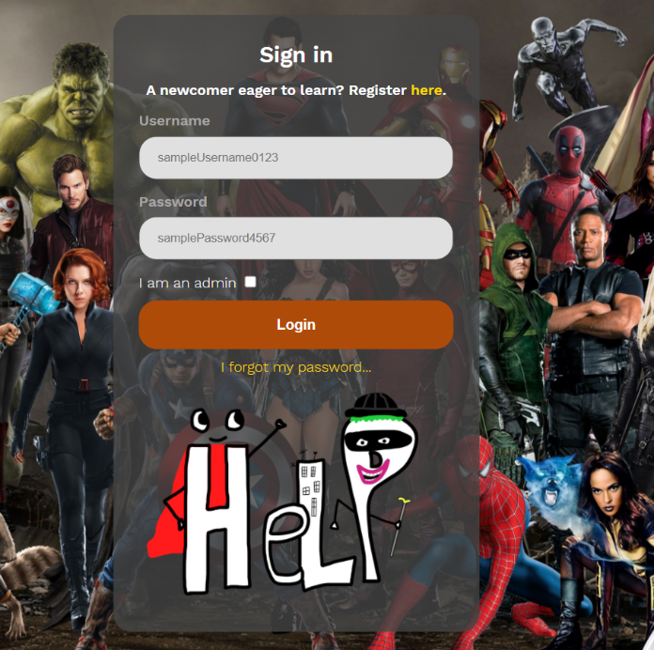

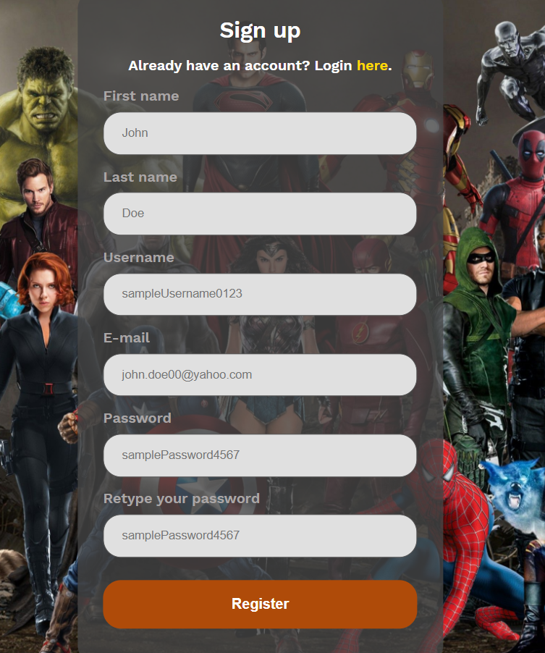

1. **Main Page**

Now this is where the magic happens. After logging in, you will be redirected to the main page where you have multiple options:

* Wiki – redirects you to the wiki page where you have information about all the heroes
* Requirements – The extensive documentation of the application, provided in the Scholarly HTML format, conforming to the IEEE System Requirements Specification Template
* Leaderboard – redirects you to a leaderboard containing the top scores achieved by players in battle mode
* Logout – located on the middle section on the top-left, logs you out of your account and redirects you to the login page
* Learning – select a superhero for which you can choose to read the wiki page related to him, or go into learning mode where you can earn the superhero by answering questions related to his wiki, so you can use him in battle mode
* 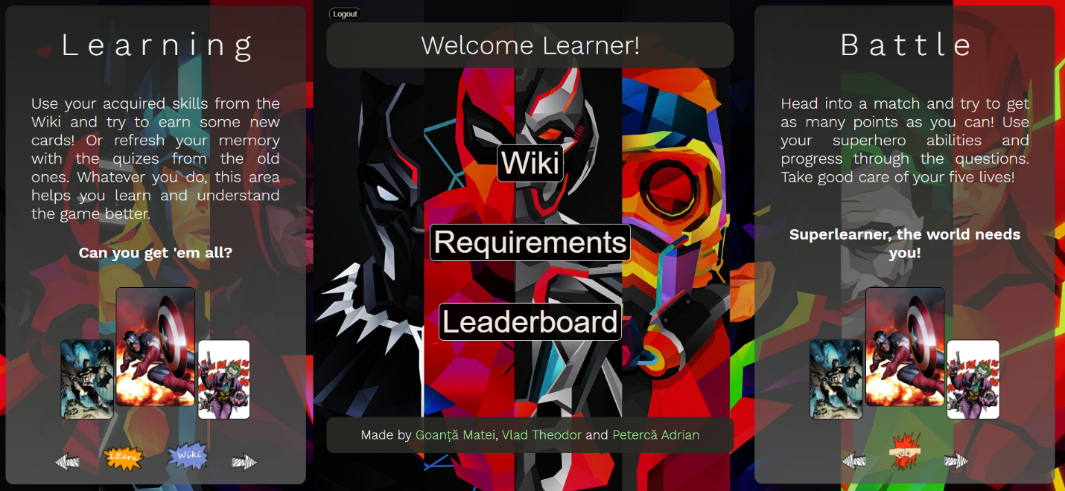Battle – choose one of your heroes to use his abilities so you can score as many points as possible to be featured in the leaderboard

1. **Wiki**

Choose a character to learn information about the domain associated to him, or just other trivial facts about the hero.

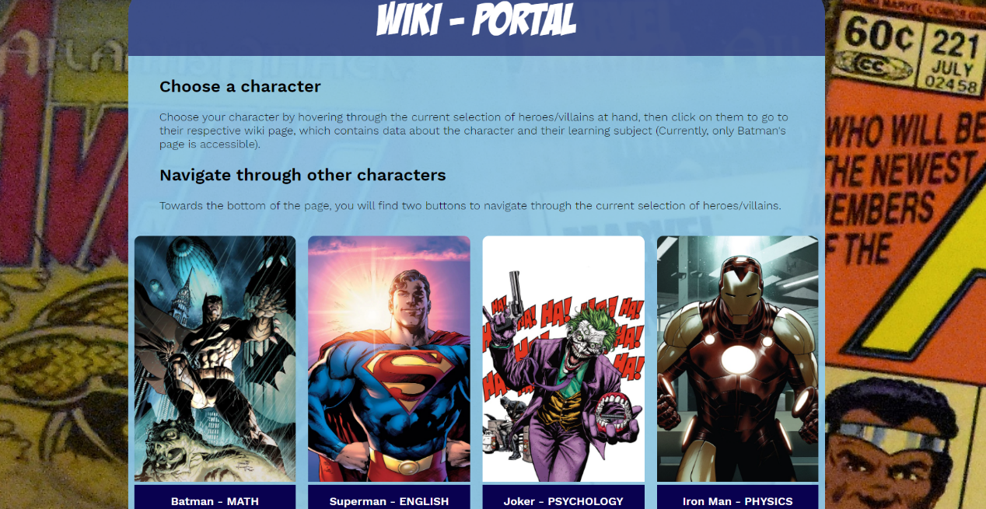

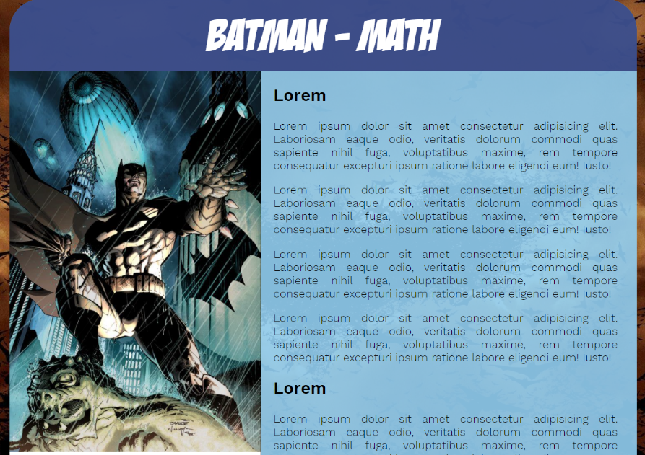

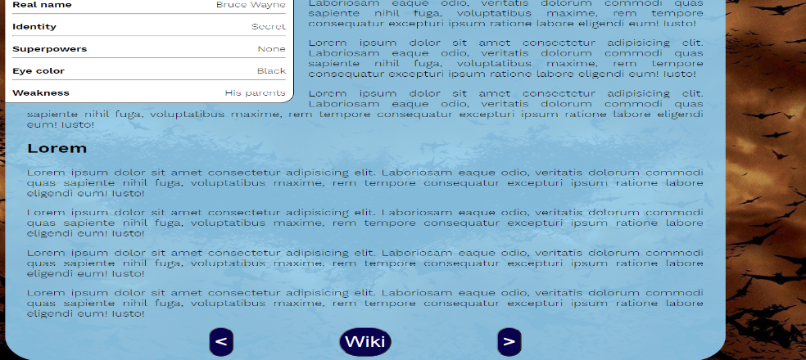

1. **Leaderboard**

This is where you can say the top 100 scores achieved by other players in battle mode and what heroes they used to achieve it. You can choose to use the button in the top-right corner to get the rankings as a RSS feed.

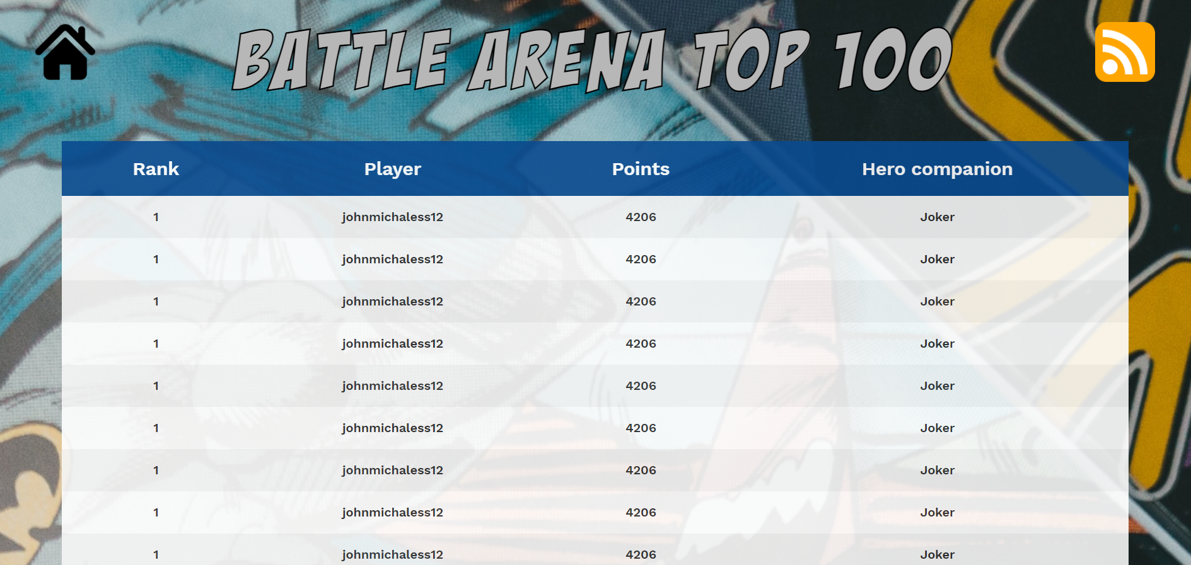

1. **Requirements**

An extensive documentation in the Scholarly HTML format, conforming to the IEEE System Requirements Specification Template

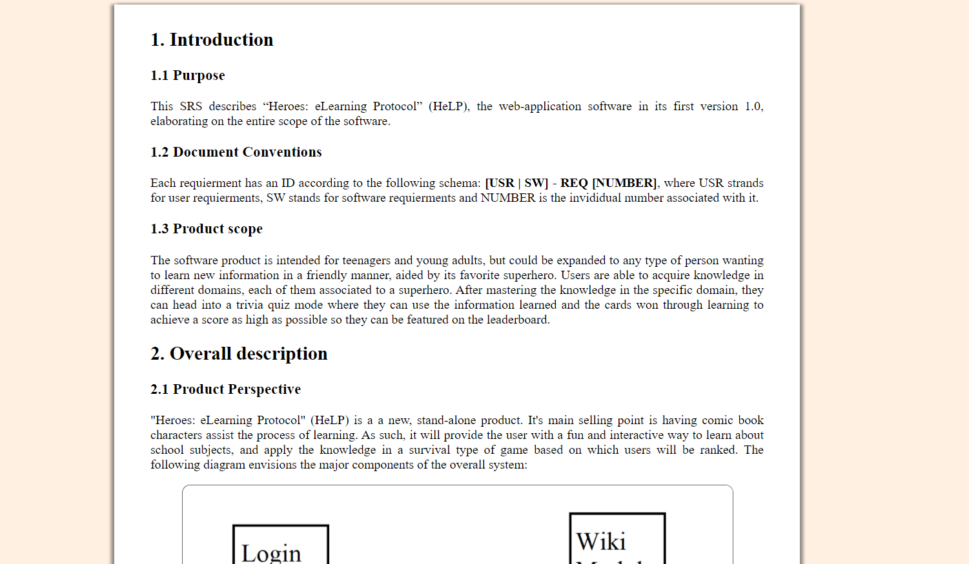

1. **Learning mode**

This is where you can unlock heroes for you to use in battle mode. All the knowledge needed to pass this quiz will be provided in the wiki section associated to the superhero. Answer all 10 questions and then submit them using the button at the bottom of the page. If you answered all of them correctly, you unlock the hero. If not, you will be shown which answers were correct and which not and you can try again. Come back here every time you want to refresh your knowledge about a subject

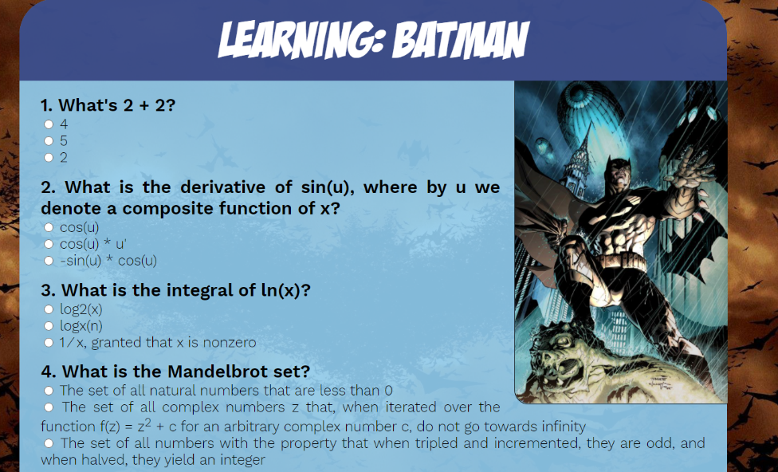

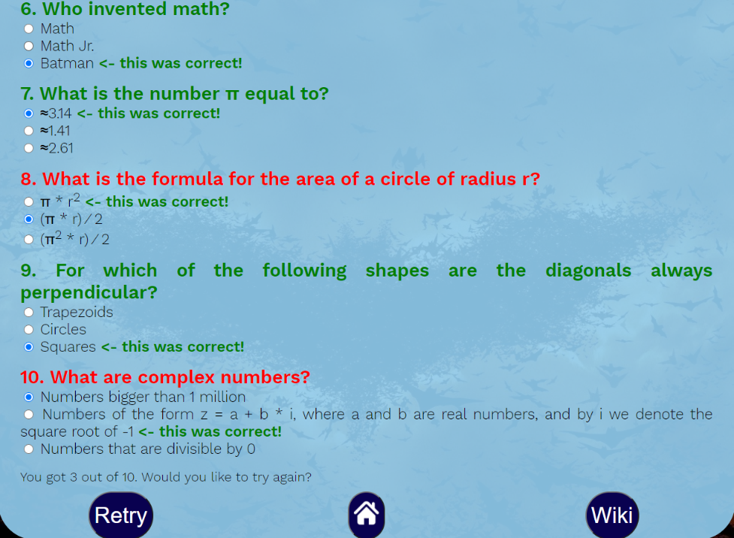

1. **Battle mode**

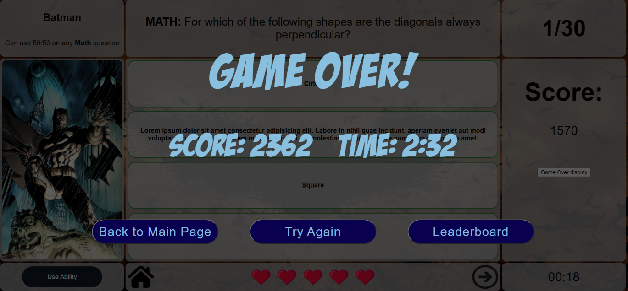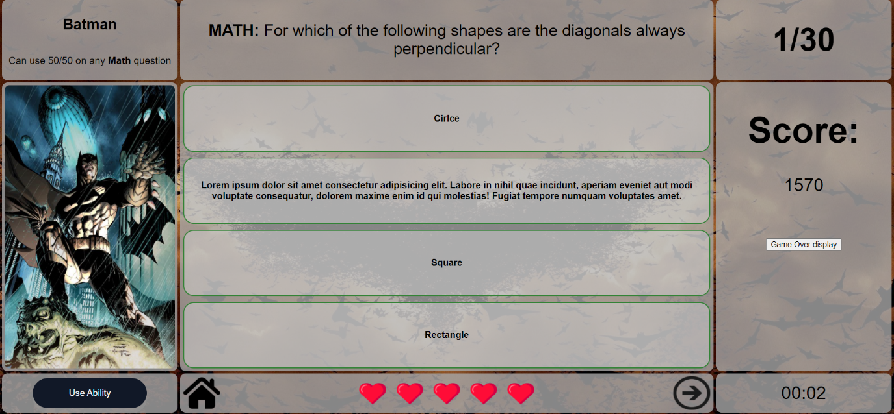Here is where you can use the knowledge you learned and the heroes you achieved to compete and earn your spot on the leaderboard. Each hero has a specific ability that they can use when a question related to their domain comes up. Use the ability by hitting the button on the bottom left. Choose the correct answer and be careful to not lose your lives. The game ends when you answer all of the questions available or when you lose all your lives. A game over screen will be displayed with your final score and the time. The final score is calculated by multiplying the score with the specific time multiplier. You can choose to take the quiz again, go to the main page or check the leaderboard.